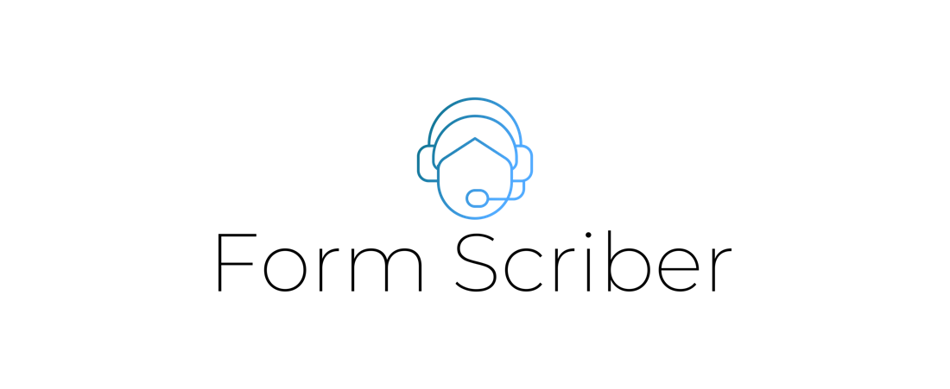

User Guide

Version 1.0

Presented by

Stefon Williams

Caleb Crickette

Thomas Barton

Eugene Kim

Nicholas Ballo

Abdul Kamara

Sohail Sobhani

Geoffrey Dean

Jean-nae Dedrick

Anthony Cedeno

SWEN 670

University of Maryland Global Campus

Project Plan Approvals

|  |  |  |
| --- | --- | --- |
| Name | Signature | Date |
| Approved by:  Dr. Mir Assadullah |  |  |
| Approved by:  "Stakeholder" |  |  |
| Approved by:  "Project Manager" |  |  |

Revision History

|  |  |  |  |
| --- | --- | --- | --- |
| Revision | Date | Name | Description of Change(s) |
| 1.0 | 02/22/2020 | Thomas Barton | Initial Release |
|  |  |  |  |
|  |  |  |  |
|  |  |  |  |
|  |  |  |  |

Table of Contents

Introduction 5

Purpose 5

Intended Audience 5

Technical Project Stakeholders 5

Technical Team Skills 6

Hardware/Software Specifications 6

Licensing Considerations 6

Deployment of the Chatbot 6

Software Description and Data 6

Characteristics, Capabilities, and Features 6

Characteristics 6

Capabilities and Limitations 7

Features 7

Support 7

Many capabilities of this application were developed primarily anchored to the Google Dialoglfow platform and conforming to its subscription plans. Google has a variety of support documents available for further information on Dialogflow. Form Scriber documentation is made by the Spring 2021 UMGC Software engineering masters course class. 7

About Dialogflow 7

Connections to The Application 8

Functional Interface 8

Troubleshooting 8

Dialogflow 8

REST API 8

Maintenance 8

Dialogflow 8

Rest API 9

Technical Support 9

Appendix A: 10

Appendix B: 10

# Introduction

Form Scriber is an application intended to help any service professional fill out forms that they would create after interacting with a client or customer. The application allows them to record information while the interact with the customer.

## Purpose

This user guide describes the Form Scriber application with a detailed description, the application’s data management, the interface, and troubleshooting and maintenance.

## Intended Audience

The audience for this document is any individual who will use the Form Scriber application in their day-to-day job activities. The reader of this document is expected to have a non-technical background, and any technical concerns should refer to the programmer’s guide.

## Technical Project Stakeholders

|  |  |  |
| --- | --- | --- |
| Name | E-mail address | Role |
| Professor Mir Assadullah | [mir.assadullah@faculty.umgc.edu](mailto:mir.assadullah@faculty.umgc.edu) | Stakeholder |
| Roy Gordon | [uspsrgordon@aol.com](mailto:uspsrgordon@aol.com) | PM Mentor |
| Johnny Lockhart | [janthony@umgc.dev](mailto:janthony@umgc.dev) | Dev Mentor |
| Stefon Williams | [swilliams538@student.umgc.edu](mailto:swilliams538@student.umgc.edu) | Project Manager |
| Caleb Crickette | [ccrickette@@student.umgc.edu](mailto:ccrickette@@student.umgc.edu) | Lead Developer |
| Thomas Barton | [tbarton7@student.umgc.edu](mailto:tbarton7@student.umgc.edu) | Developer |
| Sohail Sobhani | [ssobhani@student.umgc.edu](mailto:ssobhani@student.umgc.edu) | Developer |
| Abdul Kamara | [akamara35@student.umgc.edu](mailto:akamara35@student.umgc.edu) | Developer |
| Eugene Kim | [ekim55@student.umgc.edu](mailto:ekim55@student.umgc.edu) | Business Analyst |
| Nicholas Ballo | [nbsockem@gmail.com](mailto:nbsockem@gmail.com) | Test Engineer |
| Jean-nae’ Dedrick | [jcdedrick@gmail.com](mailto:jcdedrick@gmail.com) | Project Manager |
| Geoff Dean | [gdean5@student.umgc.edu](mailto:gdean5@student.umgc.edu) | Developer |
| Anthony Cedeno | [anthony.cedeno@gmail.com](mailto:anthony.cedeno@gmail.com) | Test Engineer |
| Ivy Pham | [ipham@student.umgc.edu](mailto:ipham@student.umgc.edu) | DevSecOps Engineer |
| Vincent Leung | [vleung1@studeng.umgc.edu](mailto:vleung1@studeng.umgc.edu) | DevSecOps Engineer |

## Technical Team Skills

The technical skills needed in order to integrate, expand, and maintain the Form Scriber tool are listed below

* Familiarity with Google Assistant or other similar voice assistant technologies.
* Familiarity with Google Docs.
* Some familiarity with REST APIs and web interfaces.

## Hardware/Software Specifications

* Smartphone running the latest OS for that device.
* Internet Connectivity
* Ability to download and install mobile application

## Licensing Considerations

The Form Scriber application is available for download and modification by anyone. Redistribution or integration into a product that is sold constitutes the need to credit this team with creation of any features used. The original Form Scriber team is NOT responsible for any handling of data, deployment, custom modification, or maintenance of systems created using the Form Scriber application.

## Deployment of the Chatbot

For instructions on how to setup and deploy the Form Scriber application, refer to the deployment guide for instructions.

# Software Description and Data

## Characteristics, Capabilities, and Features

This part will focus on the various features, capabilities, and characteristics available in the Form Scriber application. Portability, efficiency, reliability, maintainability, functionality, and usability are examined.

### Characteristics

Form Scriber is a tool which is expected to provide a specific experience to the user. Developers and technical personnel can provide additional features and enhancements to further augment a user's experience. The Dialogflow agent should remain reliable as it is a part of the GCP environment and is managed and updated by Google. Performance is primarily limited by implementation hardware speed of the webhook server, as well as internet connectivity. Usability is dependent on the UI with simplicity being a key factor in the UI design. There are however some extra steps needed to configure the storage and templates that get supplemented by help options.

### Capabilities and Limitations

The primary objective of the Form Scriber tool is the integration point for a professional and a document that needs to be filled with details.

Users will be able to accomplish the following:

* Process and Extract Shared Form Templates via Google Docs
* Dynamically Create Dialogflow Entities
* View List of Form Templates
* Populate Google Doc Fields from User Input
* Print Final Report
* Error Handling of Chat Agent
* Help and Support Articles

Form Scriber has the following limitations:

* Only guaranteed to work in English.
* Must be maintained.
* May misinterpret input.
* Requires subscription for professional Dialogflow use.

### Features

The features of the Form Scriber application allow users to fill out predefined form templates through the use of Dialogflow and Google Docs.

* Process and Extract Shared Form Templates via Google Docs

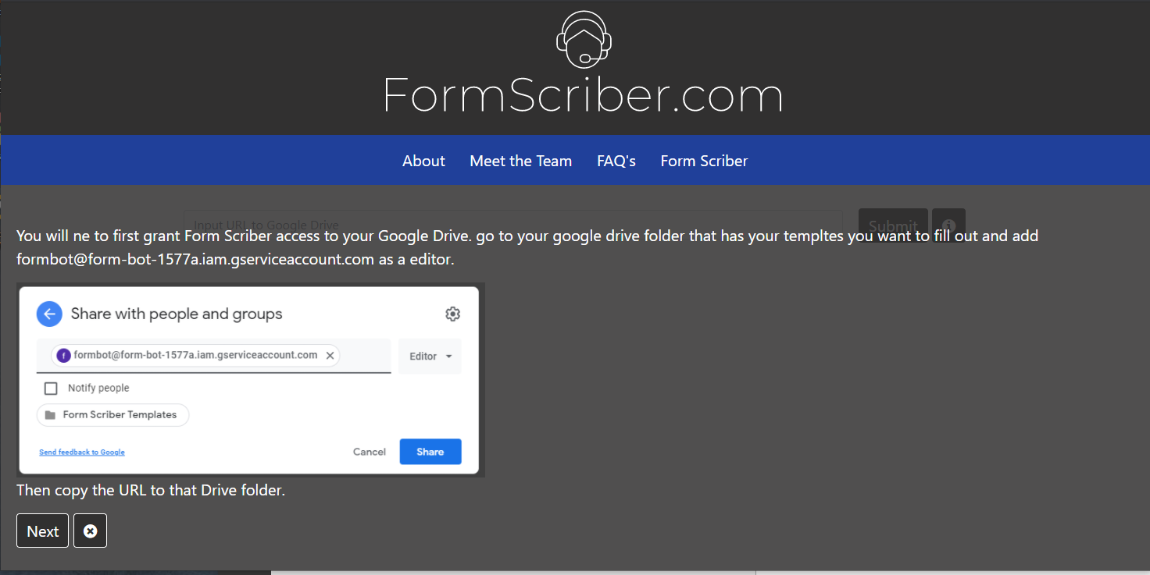

**Figure 1 – Share Form**

Form Scriber can read a shared form template and extract the form fields necessary to fill out the report.

* Dynamically Create Dialogflow Entities

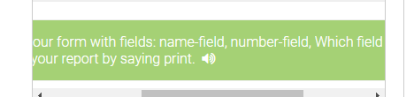

**Figure 1 – Recognizing fields**

Form Scriber can dynamically generate form field entities to be able to recognize and determine which fields to populate.

* View List of Form Templates

The user will be able to view a list of form templates and copy a shareable link to the report at the click of a button. The user will also be able to directly link to the document itself if they want to view it.

* Populate Google Doc Fields from User Input

The Dialogflow agent will recognize the voice or text of the user to populate form fields based on the user’s input.

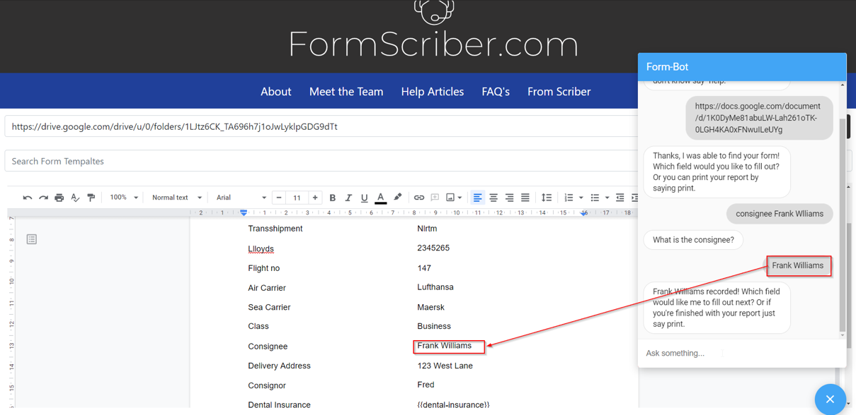

**Figure 1 – Form Scriber Demo**

* Print Final Report

The Dialogflow agent will be able to print the report if requested by the user.

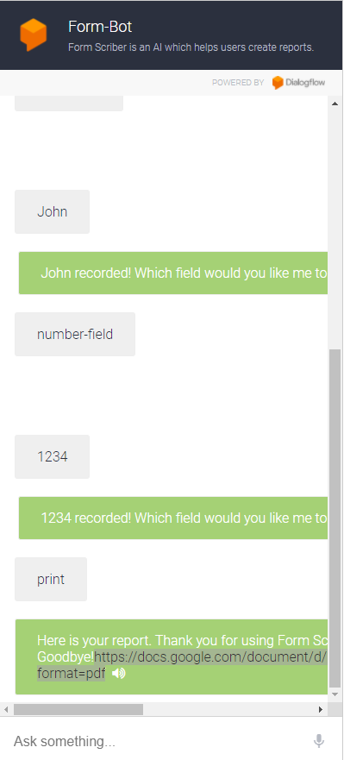

**Figure 1 – Print Option**

* Error Handling of Chat Agent

The Dialogflow agent has built-in error handling to handle misinterpreted data and will ask the user for confirmation or to try again.

* Help and Support Articles

There are a number of help and support articles that are easily accessible via the web application to guide the user through any issues they may be having with the application.

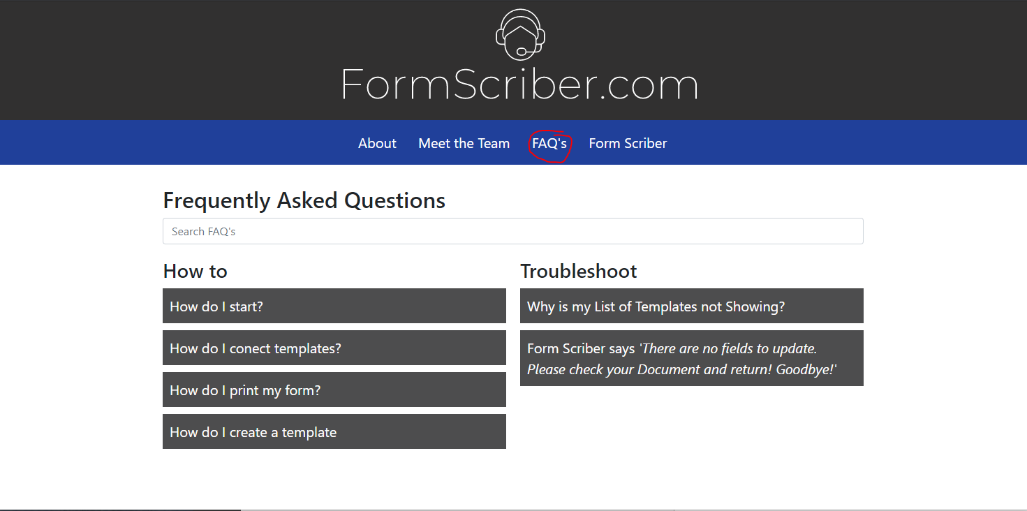**Figure 1 – FAQs**

## Support

Many capabilities of this application were developed primarily anchored to the Google Dialogflow platform and conforming to its subscription plans. Google has a variety of support documents available for further information on Dialogflow. Form Scriber documentation is made by the Spring 2021 UMGC Software engineering masters course class.

* Support page for dialogflow: <https://cloud.google.com/dialogflow/docs/support/getting-support>
* Additional documentation: <https://cloud.google.com/dialogflow#section-5>
* Tutorials for Dialogflow: <https://cloud.google.com/dialogflow/es/docs/tutorials>

## About Dialogflow

Dialogflow from Google’s perspective is tooled to be used as a customer interaction platform that allows customers to access pertinent information from a company. There are two editions created for Dialogflow, the ES basic edition, and the CX edition which have some extra features. There are many customers that currently use Dialogflow for their own purposes such as Home Depot, Blue Apron, UPS, Etsy, and PayPal to name a few examples.

## Connections to The Application

Dialogflow serves as the main engine for converting user voice or text input into processable data and then fulfilled through a REST API built in Go. The REST API handles connections to the Google Doc as well as generating the necessary intents and entities that will need to be populated in the final report.

# Functional Interface

1. Download the mobile app or visit the Form Scriber web application at <https://formscriber.com>
2. Select the Form Scriber Chat application which will open the Dialogflow Agent
3. Type or say “Start a new report” in the Dialogflow chat box.
4. Copy and paste the URL of your Google Doc with the form fields
   1. Make sure to follow the instructions on the page to share your Google Drive folder beforehand to email
5. Fill out various form fields by typing or saying the field name and the data you want to fill it with.
   1. The agent will confirm field names and you may have to repeat the data to be populated.
6. When all form fields are populated, type or say “print report” to print the report or visit the Google Doc page to view your finished report.

# Troubleshooting

### Dialogflow

Occasionally a chat agent that is interpreting the user’s voice may not understand what was said. The agent will mark that as the actual failure of interpretation and may ask the user to try again. The following steps can also be taken to resolve these issues:

* Try to record a phrase again.
* Check the internet connection.
* Move the recording device closer to the user when speaking.

### REST API

Please refer to the programmer’s guide for the Form Scriber tool to troubleshoot and resolve issues with the REST API.

# Maintenance

### Dialogflow

The Dialogflow Form Scriber agent must be registered with Google before use. Once registered, the agent will continue to function and be maintained within Google’s hardware. Additional assistance for maintenance should be directed towards Google Dialogflow Support. Support can come in the form of support packages, non-paid official support or community support. For more information visit https://cloud.google.com/dialogflow/docs/support/getting-support

### Rest API

The REST API is deployed within a Kubernetes cluster, which runs on customer hosted hardware. For Kubernetes support, visit the Kubernetes support page. <https://kubernetes.io/docs/home/>

# Technical Support

All software developed under this project is deemed to be open-source educational work and available for use and modification. Please credit this team when creating and distributing modified versions of this tool, or when using any of the techniques detailed within.

The SWEN 670 team will NOT be responsible for setting up new individual instances for other users or parties, or implementing new features or fixing any bugs found within the program. Any other user or party that wishes to use the Form Scriber tool may do so but assumes all responsibilities for hosting the application on their servers, registering the service with Google, and maintaining the application instance that they download and initiate. Any additional features and current bugs that those who wish to use this application desire must be created and/or fixed by those who download the software.